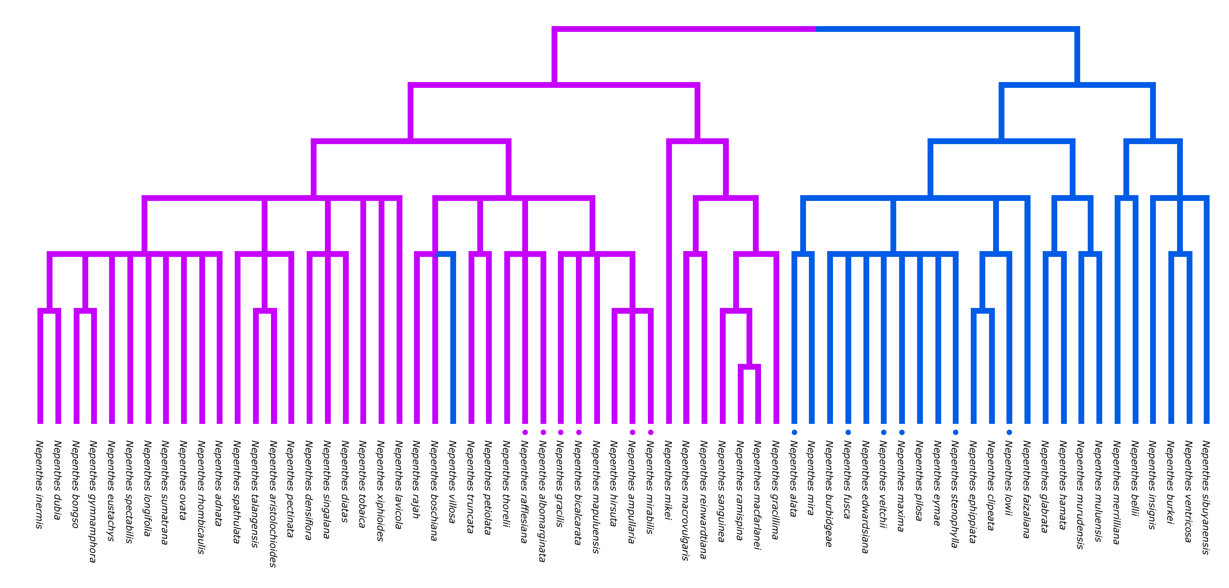

Figure 1. Reconstruction of matK *Nepenthes* molecular phylogeny from Meimburg and Hubl (2006). Highland (blue) and lowland (pink) clade pairs indicated with corresponding markers.

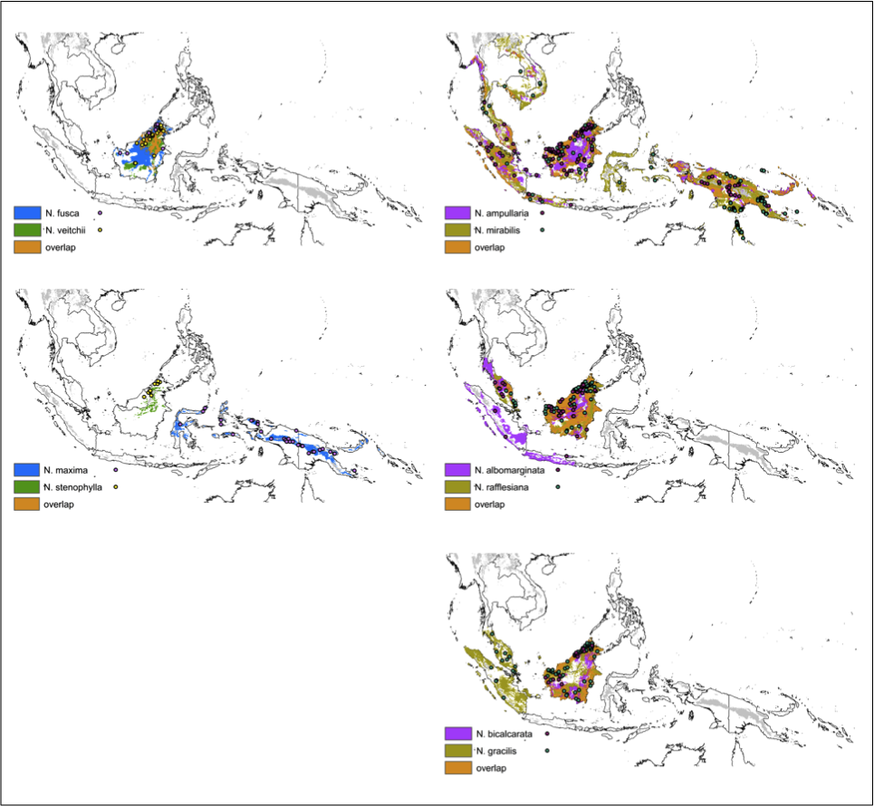

Figure 2. Predictive ecological niche models of *Nepenthes* highland (left) and lowland (right) sister-pairs inferred from environmental data and presence localities. Predicted distribution was projected only on the unit areas (van Welzen 2009) already occupied by the sister pair. Each map depicts the thresholded distribution produced with 10% training of each sister pair so that overlap between the two species can be depicted. Grey shading indicates mountainous regions ≥1000m.



Figure 3. Abiotic variable comparison of *Nepenthes* highland (left) and lowland (right) clade pairs*.* Principal component analysis (PCA) of temperature, precipitation and soil variables used in Maxent model for each pair (see Table 2).

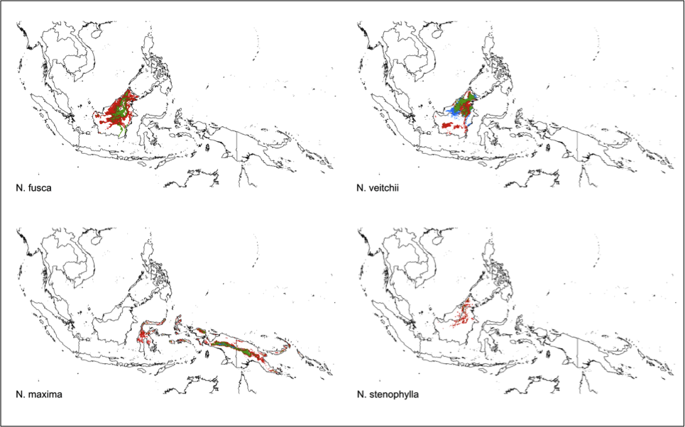

Figure 4. Predictive ecological niche models of highland *Nepenthes* species inferred from presence localities and current environmental data and subsequently projected to future (2070-2099, A2a HadCM3 scenario). Predicted distribution projected on unit areas (van Welzen 2009) already occupied by each species. Thresholded distribution produced with 10% training is depicted to show suitable habitat gained, overlapping and lost between the two timeframes.

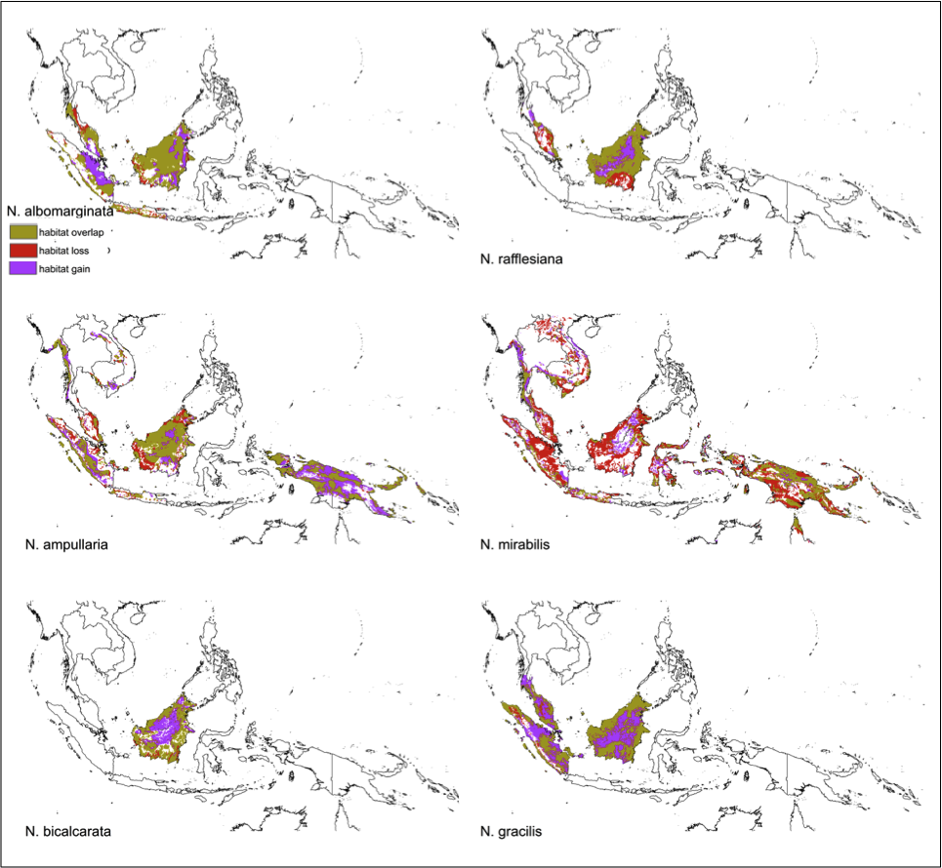

Figure 5. Predictive ecological niche models of lowland *Nepenthes* species inferred from presence localities and current environmental data and subsequently projected to future 2080 climate scenario a2a. Predicted distribution projected on unit areas (van Welzen 2009) already occupied by each species. Thresholded distribution produced with 10% training is depicted to show suitable habitat gained, overlapping and lost between the two timeframes.

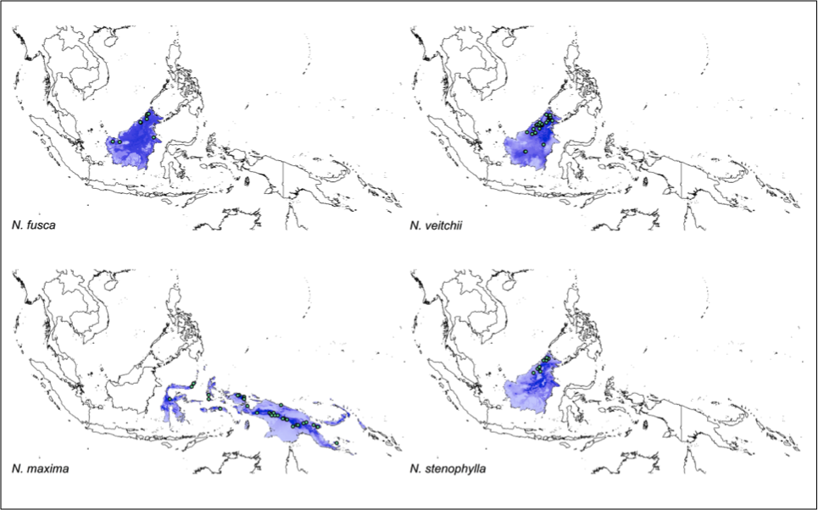

Appendix Figure 1. Predictive ecological niche models of highland *Nepenthes* species. Models inferred from presence localities (green circles) and environmental data. Predicted distribution projected on unit areas (van Welzen 2009) already occupied by each species. Color-scale indicates predictive distribution (darker shading corresponds with a more likely predicted distribution).



Appendix Figure 2. Predictive ecological niche models of lowland *Nepenthes* species. Models inferred from presence localities (brown circles) and environmental data. Predicted distribution projected on unit areas (van Welzen 2009) already occupied by each species. Color-scale indicates predictive distribution (darker shading corresponds with a more likely predicted distribution).

|  |  |  |  |  |  |
| --- | --- | --- | --- | --- | --- |
|  | **Source** | **# Specimens** | **# Unique localities** | **Referenced altitude range (m)** | **Specimen altitude range (m)** |
|
| **Highland clade species** | | | | | |
| *N. fusca* | NBC, NHN, GBIF, SI | 10 | 9 | 600-2500 | 149-1980 |
| *N. maxima* | NBC, NHN, GBIF, SI | 49 | 33 | 600-2500 | 400-3039 |
| *N. stenophylla* | NBC, NHN, GBIF, SI | 11 | 10 | 800-2600 | 409-1980 |
| *N. veitchii* | NBC, NHN, GBIF, SI | 39 | 29 | 0-1600 | 31-1568 |
| **Lowland clade species** | | | | | |
| *N. albomarginata* | NBC, NHN, GBIF, SI | 52 | 39 | 0-1200 | 8-1278 |
| *N. ampullaria* | NBC, NHN, GBIF, SI | 208 | 119 | 0-2100 | 2-2101 |
| *N. bicalcarata* | NBC, NHN, GBIF | 31 | 15 | 0-700 | 18-476 |
| *N. gracilis* | NBC, NHN, GBIF, SI | 132 | 79 | 0-1100 | 6-1564 |
| *N. mirabilis* | NBC, NHN, GBIF, SI, NYBG | 265 | 136 | 300-2100 | 4-2244 |
| *N. rafflesiana* | NBC, NHN, GBIF, SI | 141 | 77 | 0-1200 | 7-669 |

Table 1. *Nepenthes* species data records used for ecological niche modeling. Sources are indicated as follows: Naturalis Biodivercity Center (NBC), National Herbarium Netherlands (NHN), Global Biodivercity Information Facility (GBIF), the Smithsonian Institution (SI) and the New York Botanical Garden (NYBG). Referenced altitudinal ranges from McPherson (2010).

|  |  |  |  |
| --- | --- | --- | --- |
| **Variable** | **Model usage** | **Source** | **Description** |
| Bio01 |  | WorldClim | Max temperature of warmest month |
| Bio02 |  | WorldClim | Temperature annual Range |
| Bio03 | a,d,e | WorldClim | Precipitation of wettest quarter |
| Bio04 | b | WorldClim | Precipitation of driest quarter |
| Bio05 | a,b,c,d | WorldClim | Precipitation of coldest quarter |
| Bio06 |  | WorldClim | Min Temperature of Coldest Month |
| Bio07 | a,b,c,d,e | WorldClim | Max temperature of warmest month |
| Bio08 |  | WorldClim | Temperature annual Range |
| Bio09 |  | WorldClim | Precipitation of wettest quarter |
| Bio10 | e | WorldClim | Precipitation of driest quarter |
| Bio11 |  | WorldClim | Precipitation of coldest quarter |
| Bio12 | a,b,d | WorldClim | Annual Precipitation |
| Bio13 | a | WorldClim | Precipitation of Wettest Month |
| Bio14 |  | WorldClim | Precipitation of Driest Month |
| Bio15 | a,b,c,d,e | WorldClim | Precipitation Seasonality (Coefficient of Variation) |
| Bio16 | c | WorldClim | Precipitation of Wettest Quarter |
| Bio17 | e | WorldClim | Precipitation of Driest Quarter |
| Bio18 |  | WorldClim | Precipitation of Warmest Quarter |
| Bio19 | a,c,e | WorldClim | Precipitation of Coldest Quarter |
| ALT |  | WorldClim | Altitude |
| PET | c | R calcucation | Potential evapotranspiration |
| ASLA | * | ISRIC-WISE | Aluminum saturation (as % of effective CEC) |
| BSAT | a,b,e | ISRIC-WISE | Base saturation (as % of CECsoil) (%) |
| BULK |  | ISRIC-WISE | Bulk density (g cm-3) |
| CECc | a,b,c,d,e | ISRIC-WISE | Cation exchange capacity of clay size fraction (cmolckg-1) |
| CECs | b | ISRIC-WISE | Cation exchange capacity for fine earth fraction(cmolckg-1) |
| CFRAG | a,b,d,e | ISRIC-WISE | Course fragments % (>2mm) |
| CLPC | a | ISRIC-WISE | Clay mass (%) |
| CNrt | a,b,c,d,e | ISRIC-WISE | Carbon/nitrogen ratio |
| ELCO | * | ISRIC-WISE | Electrical conductivity (dS m-1) |
| ECEC | a,b,c,e | ISRIC-WISE | Effective cation exchange capacity |
| ESP | d,e | ISRIC-WISE | Exchangeable sodium percentage (% of effective CEC) |
| GYPS | * | ISRIC-WISE | Gypsym content (% mass) |
| PHAQ | c,d,e | ISRIC-WISE | Soil reaction (phh20) |
| TAWC |  | ISRIC-WISE | Available water capacity |
| SDTO |  | ISRIC-WISE | Sand mass (%) |
| STPC | a | ISRIC-WISE | Silt mass (%) |
| TAWC | a,b,c,d,e | ISRIC-WISE | Total available water capcity. (from -10 to -1500kPa) (mm) |
| TCEQ | * | ISRIC-WISE | Total carbonate equivalent (g kg-1) |
| TOTC | c,d | ISRIC-WISE | Total carbon (% mass) |
| TOTN | a | ISRIC-WISE | Total nitrogen (% mass) |

Table 2. Environmental variables used in ecological niche model production. Letters indicate variables used in modeling each clade pair as follows: (a) *N. albomargianata/N. rafflesiana,* (b) *N. fusca/N. veitchii,* (c) *N. ampullaria/N. mirabilis,* (d) *N. maxima/N. stenophylla,* (e) *N. bicalcarata/N. gracilis.* Soil variables indicated with * were eliminated from consideration prior to analyses as too few grid cells could be included due to missing data.

|  |  |  |  |  |  |  |  |  |
| --- | --- | --- | --- | --- | --- | --- | --- | --- |
|  | **Niche overlap** | | | **Identity test** | | **Background test** | | **Geographic overlap** |
| **Species pair** | *D* | | *I* | *D* | *I* | *D* | *I* | % |
| **Highland clade** | | | | | | | | |
| *N. fusca/N. veitchii* | 0.76 | 0.922 | | * | * | more*/more* | more*/more* | 25.12 |
| *N. maxima/ N. stenophylla* | 0.332 | 0.607 | | * | * | more*/more* | more*/more* | 0.00 |
| **Lowland clade** | | | | | | | | |
| *N. albomarginata/N. rafflesiana* | 0.65 | 0.861 | | * | * | less*/more* | less*/NS* | 30.87 |
| *N. ampullaria/N. mirabilis* | 0.571 | 0.816 | | * | * | less*/less* | less*/less* | 25.34 |
| *N. bicalcarata/N. gracilis* | 0.605 | 0.861 | | * | * | more*/less* | more*/less* | 22.61 |

Table 3. Niche overlap, identity, background test and geographic overlap for clade pairs of highland and lowland *Nepenthes* species*.* The background test was performed using localities of the first species listed of the pair on the background of the second and vice versa, accounting for two tests for each clade pair. * P < 0.5

|  |  |  |  |  |  |  |
| --- | --- | --- | --- | --- | --- | --- |
|  | **Suitable Present habitat (grid-cells)** | **Suitable Present habitat (km2)** | **Suitable Future habitat (grid-cells)** | **Suitable Future habitat (km2)** | **% Suitable habitat gain/loss (-)** | **% Suitable habitat overlap** |
|
| **Highland clade species** | | | | | | |
| *N. fusca* | 4,122 | 41,220 | 1,390 | 13,900 | -66.28 | 33.72 |
| *N. maxima* | 2,749 | 27,490 | 991 | 9,910 | -63.95 | 32.96 |
| *N. stenophylla* | 630 | 6,300 | 68 | 680 | -89.21 | 10.79 |
| *N. veitchii* | 2,565 | 25,650 | 1,859 | 18,590 | -27.52 | 49.04 |
| **Lowland clade species** | | | | | | |
| *N. albomarginata* | 10,047 | 100,470 | 11,765 | 117,650 | 17.10 | 89.76 |
| *N. ampullaria* | 15,389 | 153,890 | 18,288 | 182,880 | 18.84 | 79.51 |
| *N. bicalcarata* | 4,639 | 46,390 | 6,740 | 67,400 | 45.29 | 93.40 |
| *N. gracilis* | 9,699 | 96,990 | 15,133 | 151,330 | 56.03 | 94.36 |
| *N. mirabilis* | 20,957 | 209,570 | 11,942 | 119,420 | -43.02 | 40.22 |
| *N. rafflesiana* | 7,541 | 75,410 | 7,991 | 79,910 | 5.97 | 81.95 |

Table 4. Suitable present and future (2070-2099, A2a HadCM3 scenario) habitat for highland and lowland *Nepenthes* species as predicted with ecological niche modelswith 5 arcminute spatial resolution. Suitable habitat is presented in both number of grid-cells in the predicted distribution and as an estimated surface area based on this number, but not taking into account the curvature of the earth for ease of calculation.

|  |  |  |  |  |  |  |
| --- | --- | --- | --- | --- | --- | --- |
|  | | | | | | |
| **Clade**  **pair** | ***N.fusca/***  ***N.veitchii*** | ***N.maxima/***  ***N.stenophylla*** | ***N.albomarginata/***  ***N.rafflesiana*** | ***N.ampullaria/***  ***N.mirabilis*** | ***N.bicalcarata/***  ***N.gracilis*** |
| **MANOVA (Wilk's λ)** | *NS* | *\*\*\** | *\** | *\*\*\** | *NS* |
| **ANOVA**  **(Welch’s)** | bio_04 | bio_03** | bio03 | bio_05 | bio_03 |
|  | bio_05 | bio_05 | bio05 | bio_07*** | bio_07 |
|  | bio_12 | bio_12 | bio12 | bio_16* | bio_15 |
|  | bio_15 | bio_15 | bio13 | bio_19*** | bio_17* |
|  | bsat | cec* | bio15 | cec | bio_19 |
|  | cec | cecs** | bio19 | cfrag** | bsat |
|  | cecs | cfrag** | bsat | cnrt* | cec |
|  | cfrag | cnrt | cec | ecec | cecs |
|  | cnrt | esp*** | cfrag | pet*** | cfrag |
|  | ecec | ph | clpc | ph* | cnrt* |
|  | tawc | tawc* | cnrt | tawc* | ecec |
|  |  | totc*** | ecec | totc* | esp |
|  |  |  | tawc |  | ph* |
|  |  |  | totn |  | tawc |

Appendix Table 1.Multiple analysis of varience (MANOVA) and analysis of variance (ANOVA) for each *Nepenthes* clae pair. MANOVA presented on first line with *P* threshold only. ANOVA presented with *P* threshold for each environmental variable used in ecological niche model. * P < 0.5, ** P < 0.1, *** P < 0.01.